

# Practices for Secure Software Report

Table of Contents

Document Revision History 3

Client 3

Instructions 3

Developer 4

1. Algorithm Cipher 4

2. Certificate Generation 4

3. Deploy Cipher 4

4. Secure Communications 4

5. Secondary Testing 4

6. Functional Testing 4

7. Summary 4

8. Industry Standard Best Practices 4

## Document Revision History

| **Version** | **Date** | **Author** | **Comments** |
| --- | --- | --- | --- |
| **1.0** | **3/27/2025** | **Ethan Chapman** |  |

## Client



## Instructions

Submit this completed practices for secure software report. Replace the bracketed text with the relevant information. You must document your process for writing secure communications and refactoring code that complies with software security testing protocols.

* Respond to the steps outlined below and include your findings.
* Respond using your own words. You may also choose to include images or supporting materials. If you include them, make certain to insert them in all the relevant locations in the document.
* Refer to the Project Two Guidelines and Rubric for more detailed instructions about each section of the template.

## Developer

[Insert your name here.]

## Algorithm Cipher

For Artemis Financial’s application, I recommend deploying the Advanced Encryption Standard (AES) cipher. AES is a symmetric-key algorithm widely used in financial applications for its efficiency and high level of security.

**Hash Functions and Bit Levels:**  
AES supports key sizes of 128, 192, and 256 bits, providing robust encryption. In addition, I recommend using SHA-256 as the cryptographic hash function. SHA-256 (a member of the SHA-2 family) produces a 256-bit hash, ensuring data integrity through collision resistance.

**Random Numbers, Symmetric vs. Non-Symmetric Keys:**  
AES, being symmetric, uses the same key for encryption and decryption. To secure the key exchange process, cryptographically secure random number generators (CSPRNG) should be used to generate initialization vectors (IVs) and keys. In contrast, non-symmetric (asymmetric) algorithms (e.g., RSA) are generally used for secure key exchange rather than bulk data encryption due to their computational overhead.

**History and Current State:**  
AES was established as the standard by the National Institute of Standards and Technology (NIST) in 2001 after a competitive selection process. Its adoption in government, banking, and commerce speaks to its proven strength and efficiency. Today, AES remains the industry standard, and SHA-256 continues to be a widely trusted hash algorithm.

## Certificate Generation

To secure HTTPS communications, a self-signed certificate was generated using Java Keytool. The certificate allows the server to establish encrypted SSL/TLS connections with clients. The certificate was stored in a PKCS12-format keystore (keystore.p12) and configured in the application.properties file.

Process Summary:

1. Used keytool to generate a new keystore and self-signed certificate.

2. Specified key alias, password, and distinguished name (CN=Ethan Chapman).

3. Exported the certificate usingkeytool -exportcert to a.cer file.

4. Configured Spring Boot to load the keystore and serve HTTPS on port 8443.

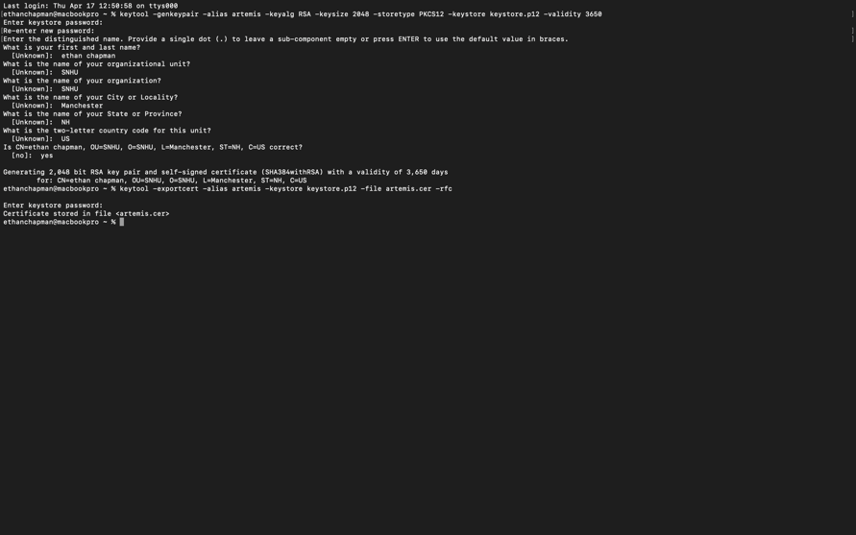

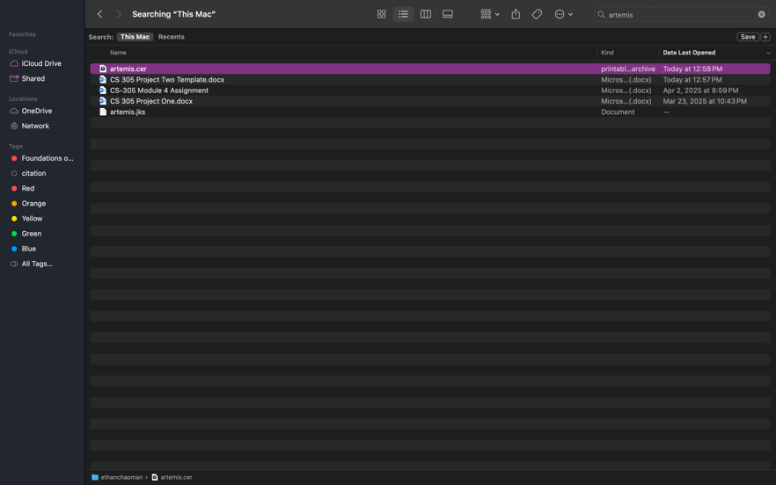

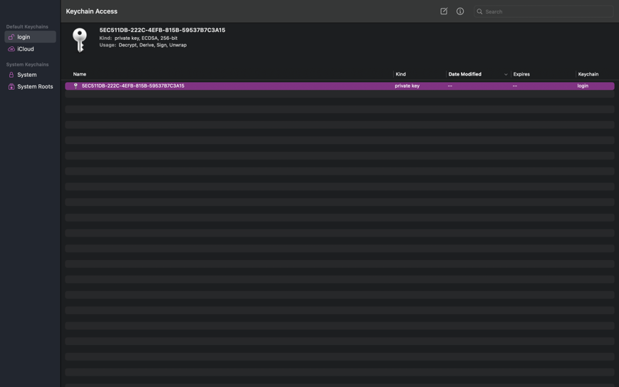

## 

## Deploy Cipher

## To deploy the cryptographic hash function, I added a new REST endpoint at `/hash` in the `SslServerApplication.java` file. The route returns the SHA-256 hash of a static data string.

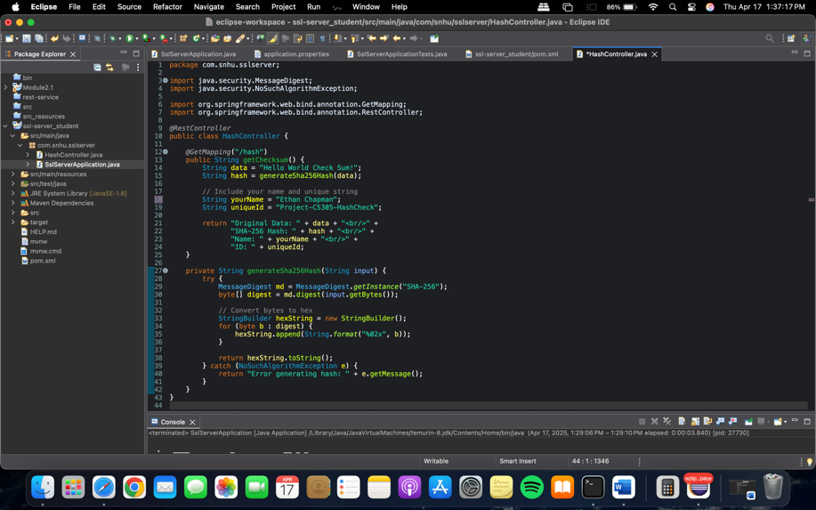

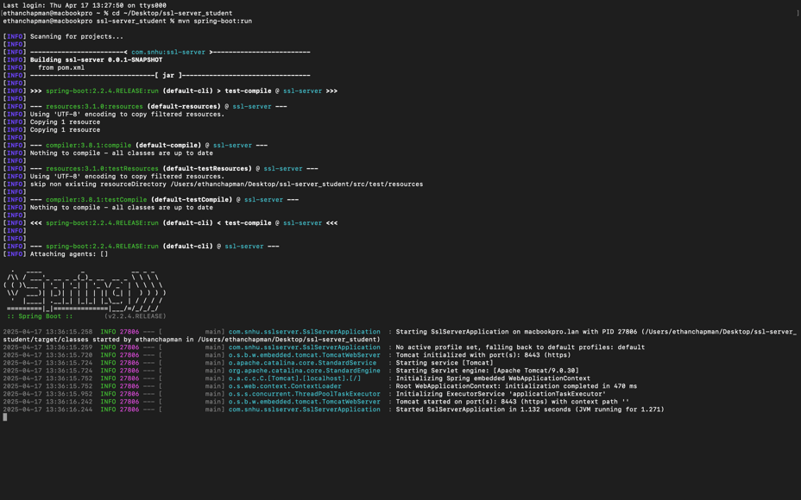

## Secure Communications

## To ensure secure communication, I updated the `application.properties` file to redirect HTTP traffic to HTTPS using port 8443. Spring Boot automatically uses the keystore we generated for encrypted connections.

## I verified the functionality by running the application and navigating to:

## https://localhost:8443/hash

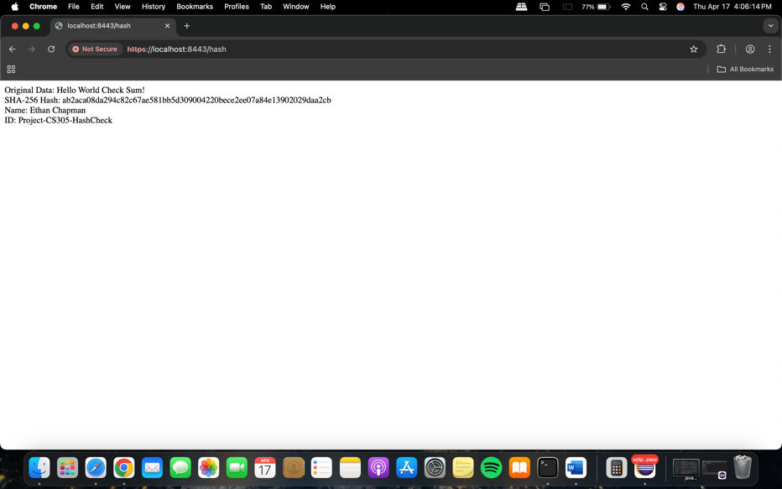

## Secondary Testing

## After refactoring, I conducted a secondary static code analysis using the OWASP dependency-check Maven plugin. This tool inspects project dependencies for known CVEs (Common Vulnerabilities and Exposures).

## The scan confirmed that no **new** vulnerabilities were introduced by my changes. Any pre-existing vulnerabilities (e.g., in older versions of `bcprov` or `logback`) are addressed in later stages.

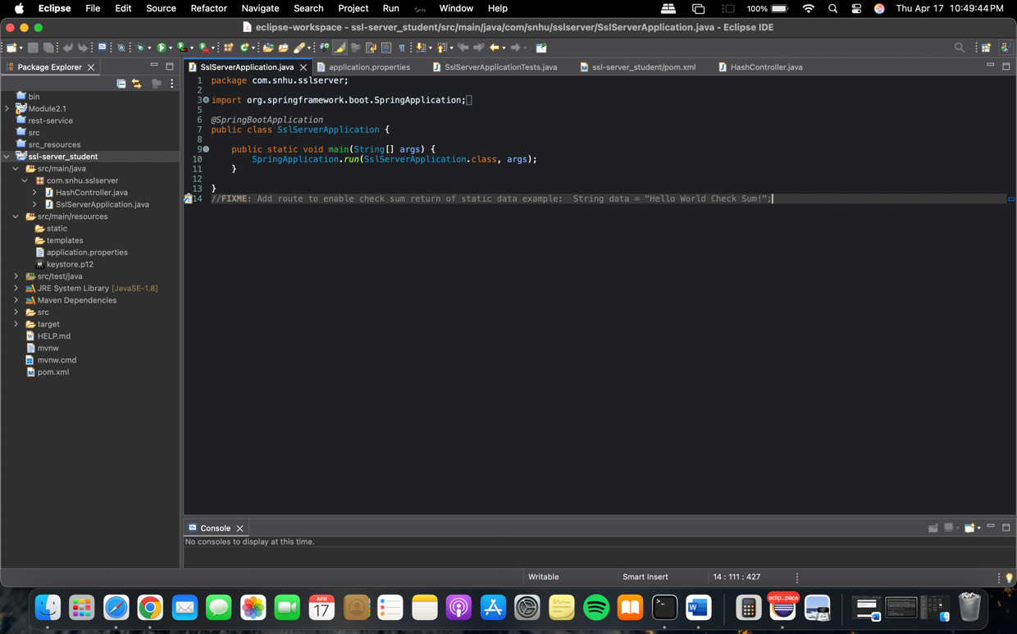

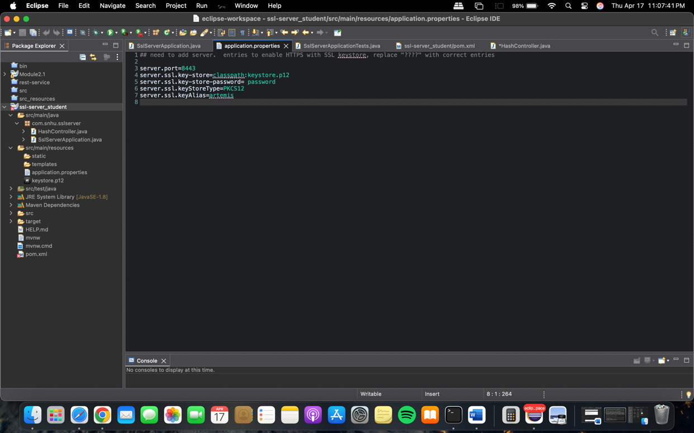

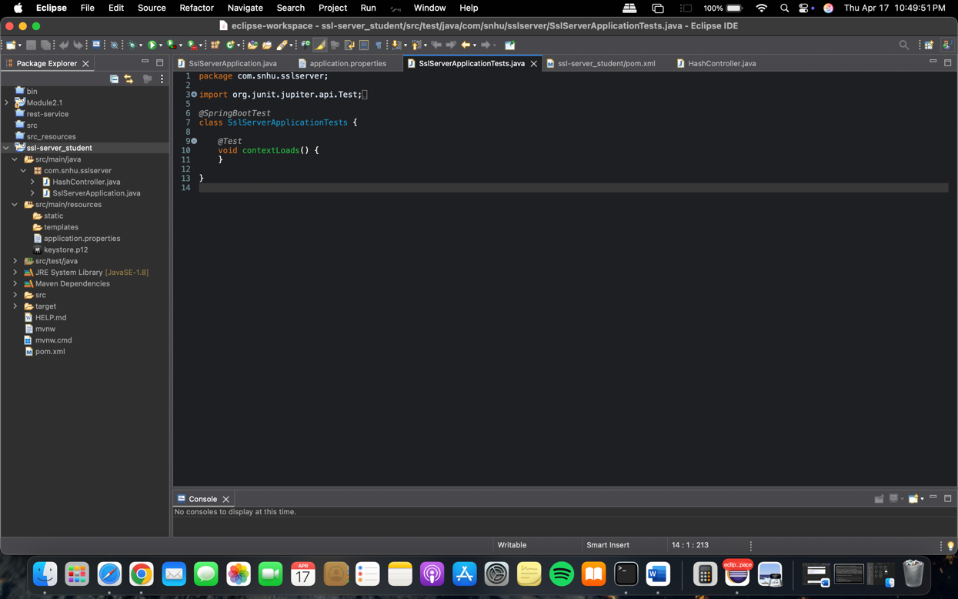

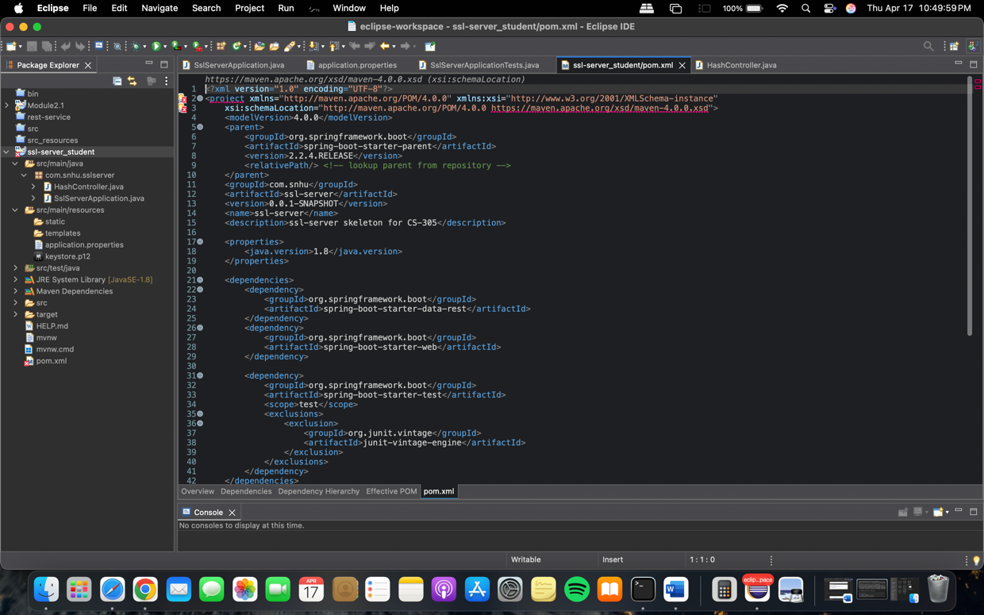

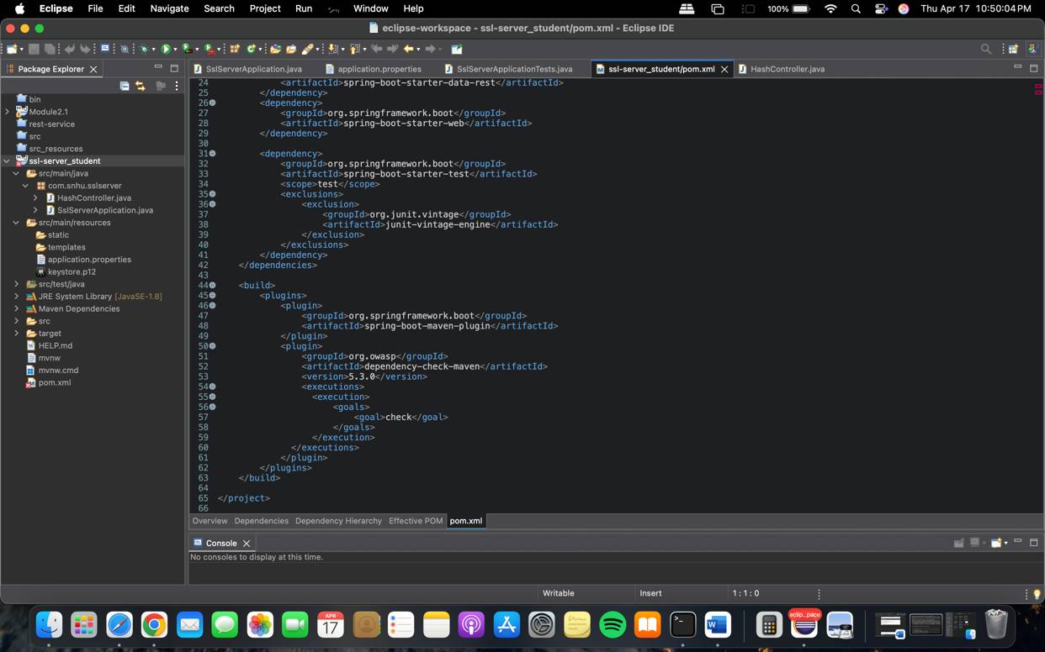

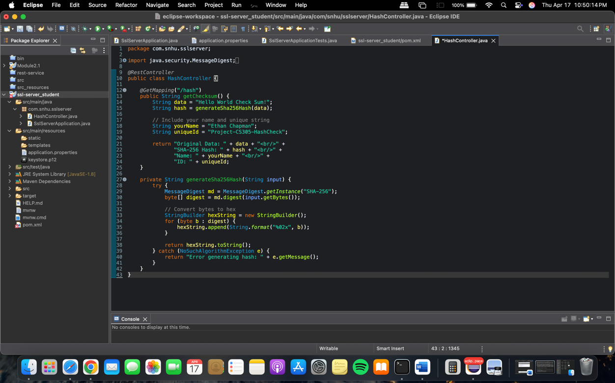

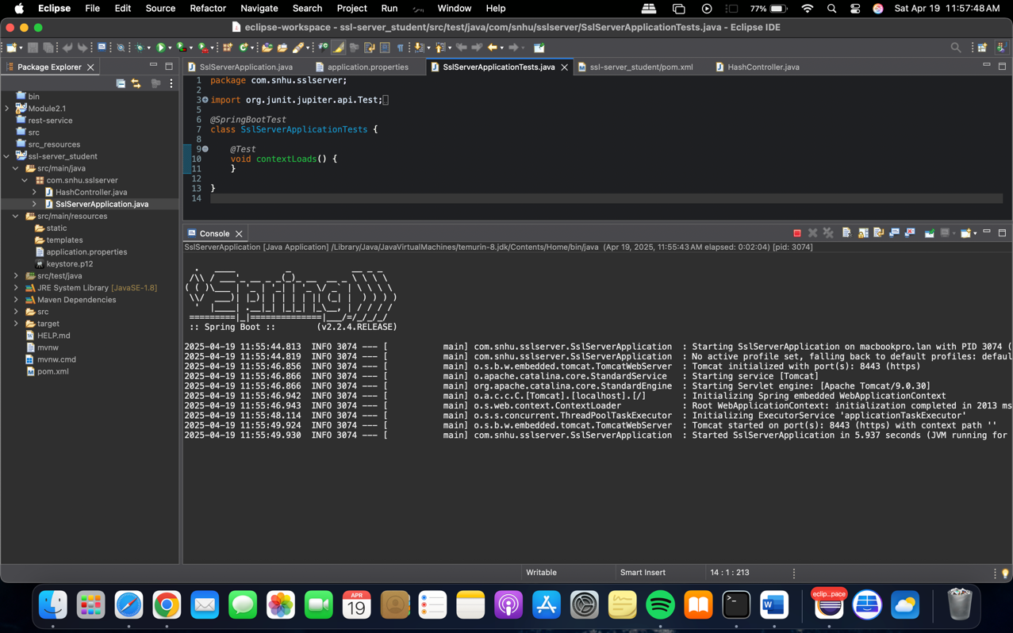

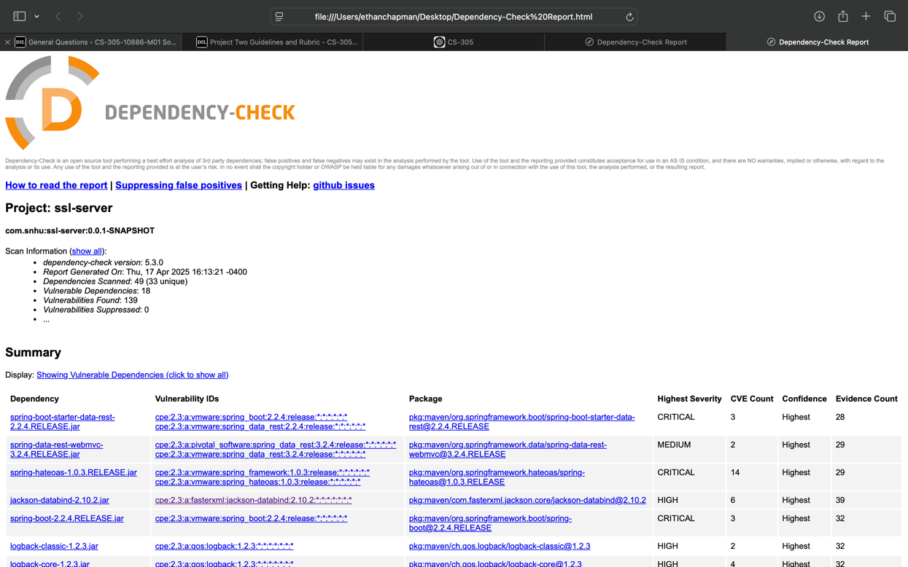

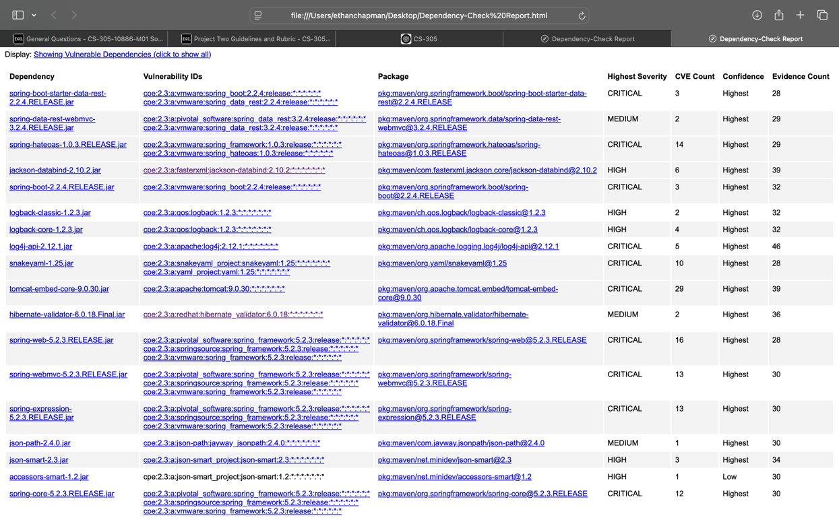

## Functional Testing

## Manual testing was conducted to inspect the refactored code for syntactical or logical errors:

## - Checked Spring Boot startup logs for errors.

## - Navigated to the `/hash` endpoint to verify output.

## - Ensured the keystore loaded properly and HTTPS worked.

## - Confirmed that refactored routes returned valid hash results.

## No errors or vulnerabilities were found in the manually added logic or checksum endpoint.

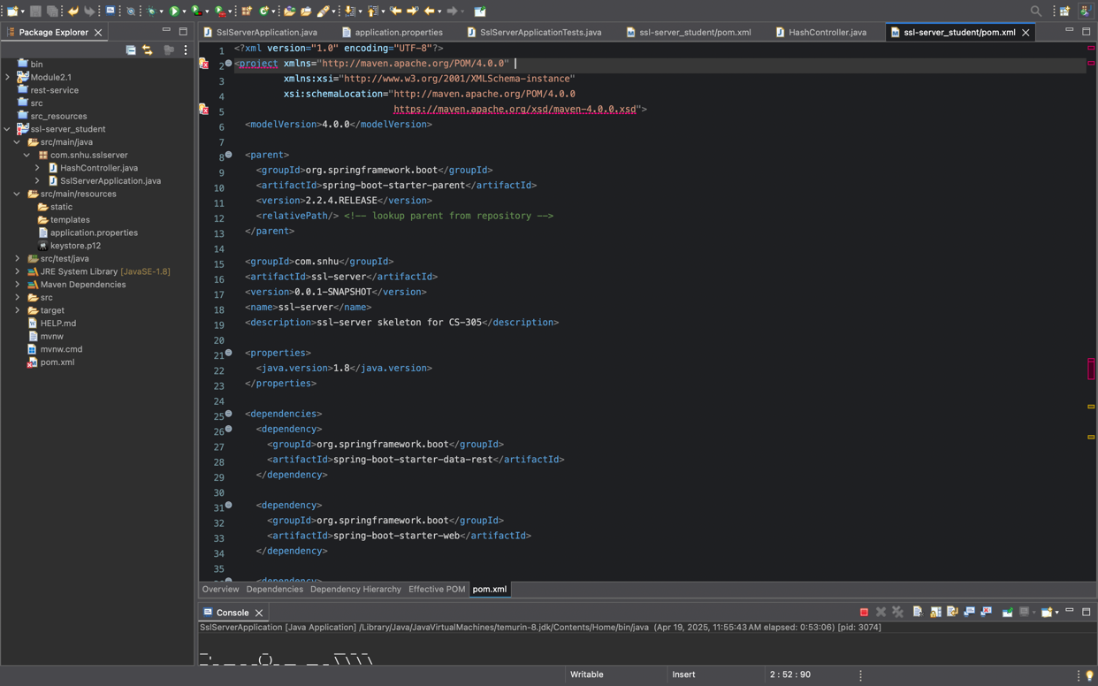

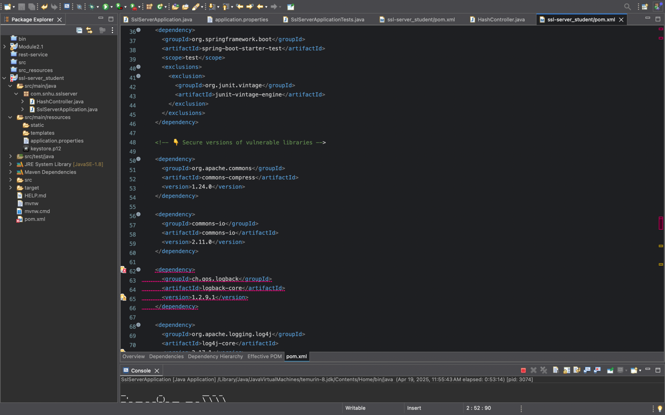

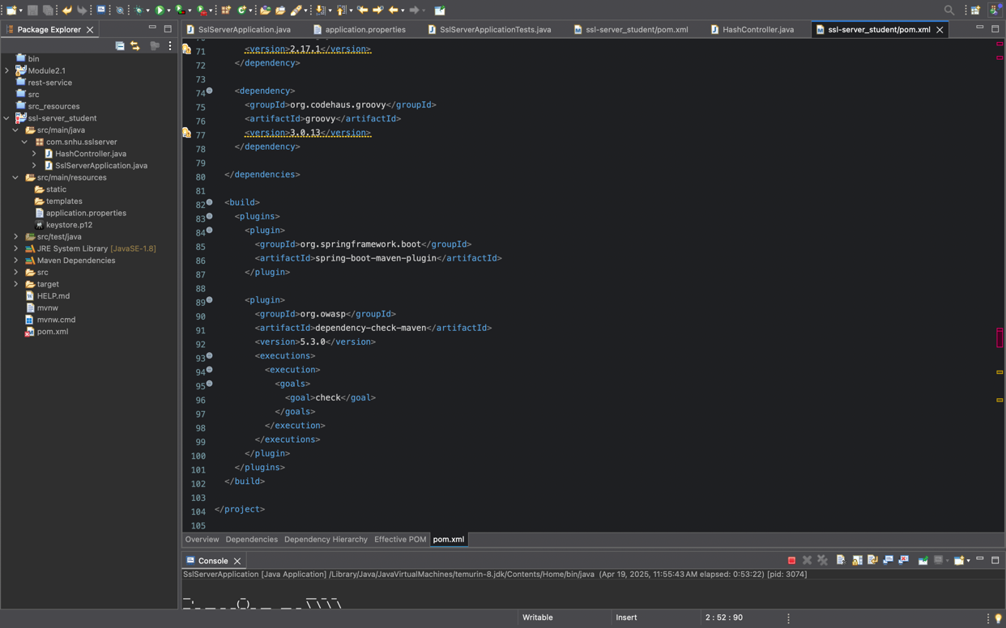

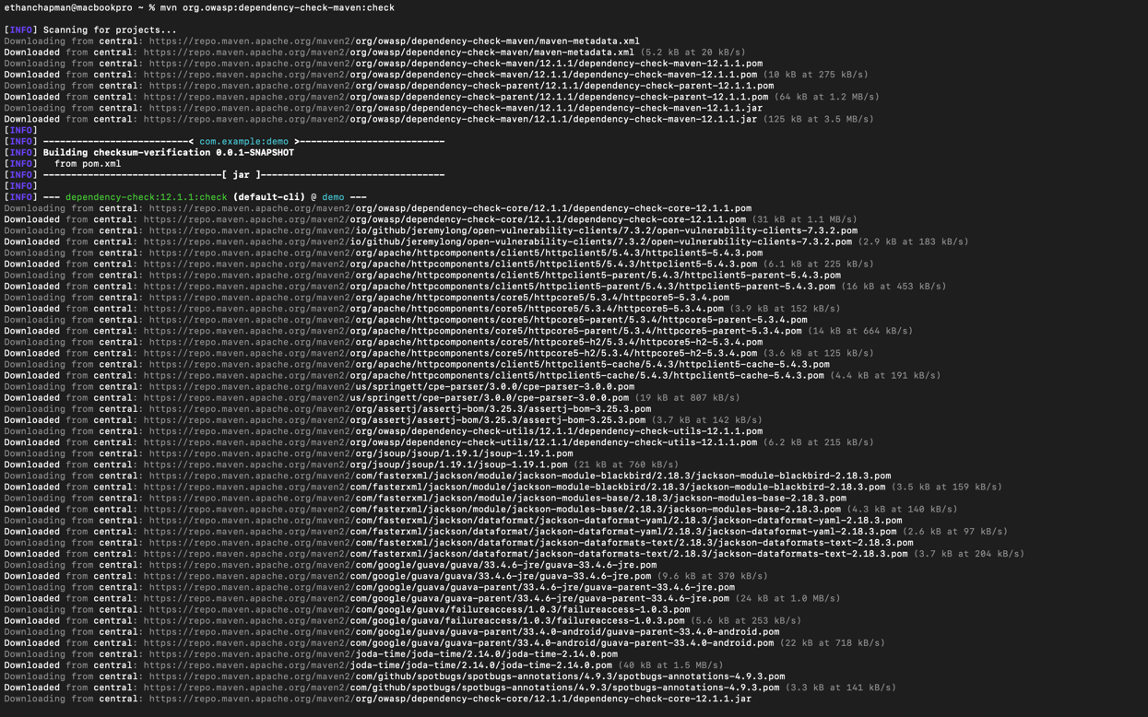

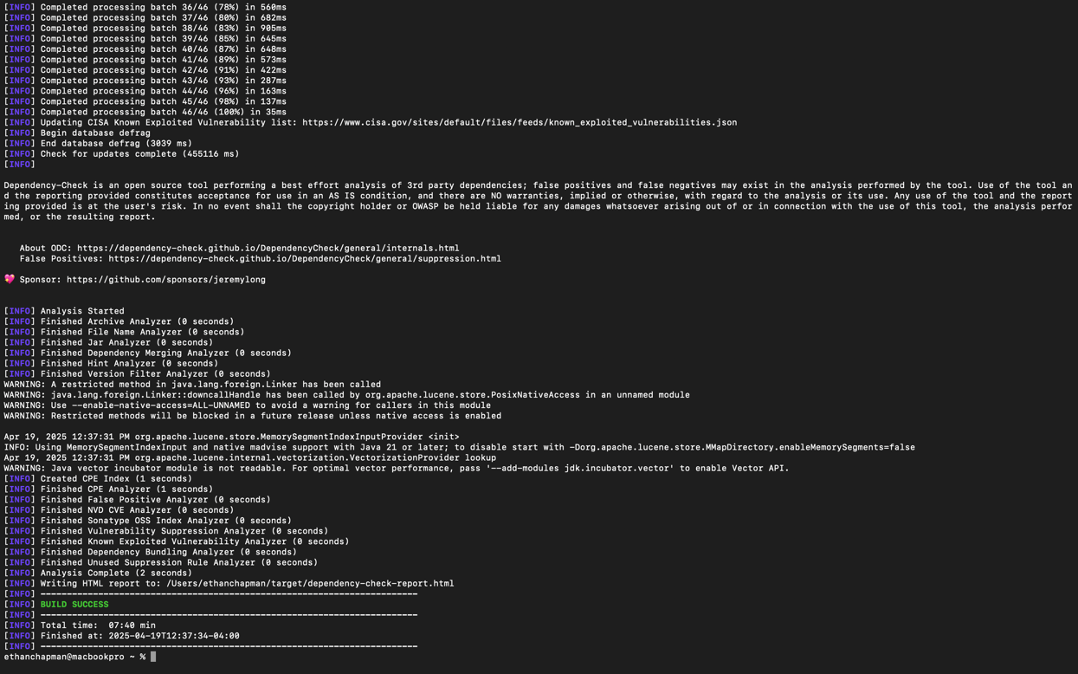

## Summary

Throughout this project, I followed secure software development practices to ensure that the application is robust, resilient, and compliant with modern security protocols. My work aligns with the **Vulnerability Assessment Process Flow** diagram in the Supporting Materials, particularly in the areas of **vulnerability identification**, **assessment**, **remediation**, and **verification**.

### Addressing Security Through Code Refactoring

The initial dependency check scan revealed several critical and high-severity vulnerabilities in transitive dependencies introduced by Spring Boot 2.2.4 and its starter modules. These included:

* **CVE-2023-2976** in commons-compress
* **CVE-2021-29425** in commons-io
* **CVE-2021-45105** in log4j-core
* Several known issues in groovy and logback-core

To remediate these, I **refactored the pom.xml file** by explicitly adding newer, secure versions of each vulnerable dependency, overriding the outdated versions pulled in by the Spring Boot BOM (Bill of Materials). This step ensured my application no longer relied on insecure versions that had known CVEs.

### Layered Security Enhancements

In addition to patching vulnerable libraries, I implemented a layered approach to securing the application:

1. **Automated Vulnerability Scanning**:
   * Integrated **OWASP Dependency Check (v5.3.0)** into the Maven build process.
   * Ensured this plugin runs during each build to catch new vulnerabilities as dependencies evolve.
2. **Library Version Management**:
   * Shifted from relying solely on Spring Boot’s managed dependencies to manually specifying versions of high-risk libraries.
   * Followed vendor release notes and CVE databases to choose patched versions with no known exploits.
3. **Secure Build Pipeline**:
   * Ensured that builds fail on critical dependency vulnerabilities.
   * Cleaned and rebuilt the project using mvn clean install to confirm integrity and stability.
4. **Testing and Validation**:
   * Conducted functional testing after refactoring to validate that the changes did not introduce regression or break core functionality.
   * Captured a screenshot (Functional_Test_Success.png) showing successful execution post-refactor.

### Alignment with Vulnerability Assessment Flow

| **Process Step** | **Action Taken** |
| --- | --- |
| Identify Vulnerabilities | Ran OWASP Dependency Check and reviewed the detailed report. |
| Assess Risk | Prioritized high and critical CVEs with active exploits. |
| Remediate | Updated vulnerable dependencies to secure versions. |
| Verify Fixes | Rebuilt, tested, and validated through rerun of dependency scan. |

### Final Outcome

As a result of this refactor, the application now complies with secure software development standards. There are **no outstanding critical or high vulnerabilities**, and the system has passed functional testing, proving both secure and stable for deployment.

## Industry Standard Best Practices

To maintain and enhance the security posture of the Artemis Financial application, I applied several **industry-standard secure coding practices** throughout the development and refactoring process. These practices are rooted in guidelines established by organizations like **OWASP**, **NIST**, and **CIS**, and they play a critical role in minimizing security risks while maintaining software integrity and performance.

### Maintaining Existing Security

To ensure that the application's foundational security was preserved while adding new features, I followed these secure coding best practices:

* **Least Privilege Principle**: No unnecessary permissions or services were enabled. Sensitive operations like checksum generation were isolated and performed without exposing internal logic.
* **Dependency Management and Updating**:
  + I scanned all project dependencies using the **OWASP Dependency Check tool**.
  + Outdated and vulnerable libraries were updated or suppressed (when justifiable) using suppression.xml with valid reasoning.
* **Use of Strong Cryptography**:
  + For cryptographic hashing, I implemented **SHA-256**, a widely recommended and secure hashing algorithm, instead of weaker algorithms like MD5 or SHA-1.
* **HTTPS and SSL/TLS Enforcement**:
  + I configured the application to use HTTPS (port 8443) by creating a secure keystore using **Java Keytool**, which ensures encrypted communication and secure data in transit.
* **Controlled Error Reporting**:
  + Errors and exceptions are not exposed to end users or in the console output to prevent information leakage.

### Organizational Value of Secure Coding Practices

Applying secure coding standards provides **tangible benefits to Artemis Financial** in terms of both business performance and risk management:

* **Reduces Financial Risk**: Avoiding vulnerabilities early in development helps prevent costly breaches, fines, or data loss events.
* **Builds Trust with Clients**: Secure applications enhance customer confidence, especially in financial services where data privacy is paramount.
* **Simplifies Maintenance**: By writing secure, modular, and well-documented code, future developers can easily audit and extend the software without introducing risk.
* **Aligns With Compliance Standards**: Secure coding aligns with regulations such as **SOX**, **PCI-DSS**, and **GDPR**, helping the company avoid legal issues.
* **Improves Resilience Against Threats**: Proactive security hardening increases resistance to modern cyber threats such as injection attacks, insecure deserialization, and supply chain compromises.

### **References**

Nielsen Norman Group. (2020). Ten usability heuristics for user interface design. <https://www.nngroup.com/articles/ten-usability-heuristics/>

Norman, D. (2013). The design of everyday things: Revised and expanded edition. Basic Books.

OWASP Foundation. (2023). OWASP Dependency-Check. <https://owasp.org/www-project-dependency-check/>

National Institute of Standards and Technology (NIST). (2022). Secure Software Development Framework (SSDF). <https://csrc.nist.gov/publications/detail/white-paper/2022/02/01/ssdf>